Exception Handling in Java

### Advantage of Exception Handling

The core advantage of exception handling is **to maintain the normal flow of the application**. Exception normally disrupts the normal flow of the application that is why we use exception handling. Let's take a scenario:

1. statement 1;
2. statement 2;
3. statement 3;
4. statement 4;
5. statement 5;//exception occurs
6. statement 6;
7. statement 7;
8. statement 8;
9. statement 9;
10. statement 10;

Suppose there is 10 statements in your program and there occurs an exception at statement 5, rest of the code will not be executed i.e. statement 6 to 10 will not run. If we perform exception handling, rest of the statement will be executed. That is why we use exception handling in java.

## Hierarchy of Java Exception classes

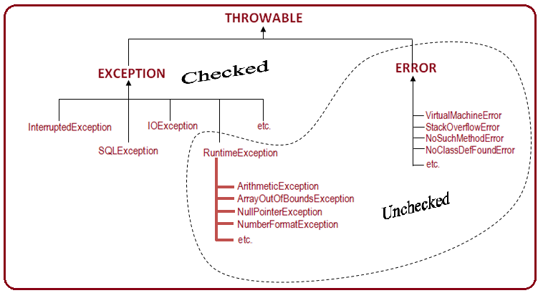

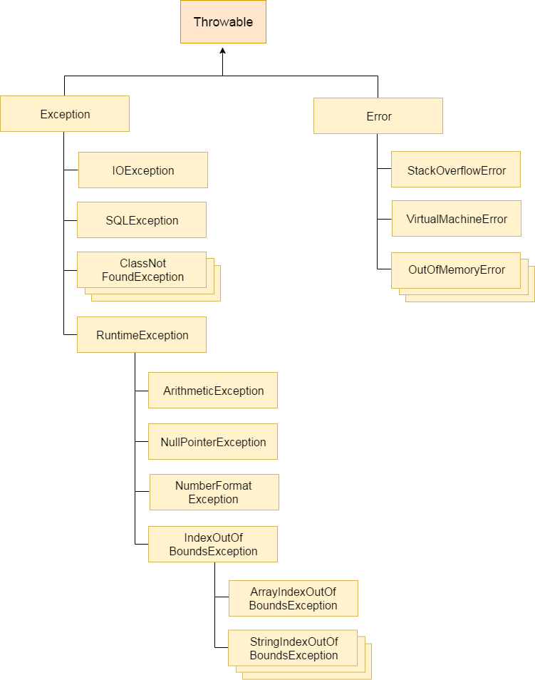

### Types of Exception

There are mainly two types of exceptions: checked and unchecked where error is considered as unchecked exception. The sun microsystem says there are three types of exceptions:

1. Checked Exception
2. Unchecked Exception
3. Error

## Difference between checked and unchecked exceptions

### 1) Checked Exception

The classes that extend Throwable class except RuntimeException and Error are known as checked exceptions e.g.IOException, SQLException etc. Checked exceptions are checked at compile-time.

### 2) Unchecked Exception

The classes that extend RuntimeException are known as unchecked exceptions e.g. ArithmeticException, NullPointerException, ArrayIndexOutOfBoundsException etc. Unchecked exceptions are not checked at compile-time rather they are checked at runtime.

### 3) Error

Error is irrecoverable e.g. OutOfMemoryError, VirtualMachineError, AssertionError etc.

### Common scenarios where exceptions may occur

There are given some scenarios where unchecked exceptions can occur. They are as follows:

### 1) Scenario where ArithmeticException occurs

If we divide any number by zero, there occurs an ArithmeticException.

1. **int** a=50/0;//ArithmeticException

### 2) Scenario where NullPointerException occurs

If we have null value in any variable, performing any operation by the variable occurs an NullPointerException.

1. String s=**null**;
2. System.out.println(s.length());//NullPointerException

### 3) Scenario where NumberFormatException occurs

The wrong formatting of any value, may occur NumberFormatException. Suppose I have a string variable that have characters, converting this variable into digit will occur NumberFormatException.

1. String s="abc";
2. **int** i=Integer.parseInt(s);//NumberFormatException

s

### 4) Scenario where ArrayIndexOutOfBoundsException occurs

If you are inserting any value in the wrong index, it would result ArrayIndexOutOfBoundsException as shown below:

1. **int** a[]=**new** **int**[5];
2. a[10]=50; //ArrayIndexOutOfBoundsException

Java Custom Exception

If you are creating your own Exception that is known as custom exception or user-defined exception. Java custom exceptions are used to customize the exception according to user need.

By the help of custom exception, you can have your own exception and message.

Let's see a simple example of java custom exception.

1. **class** InvalidAgeException **extends** Exception{
2. InvalidAgeException(String s){
3. **super**(s);
4. }
5. }
6. **class** TestCustomException1{
8. **static** **void** validate(**int** age)**throws** InvalidAgeException{
9. **if**(age<18)
10. **throw** **new** InvalidAgeException("not valid");
11. **else**
12. System.out.println("welcome to vote");
13. }
15. **public** **static** **void** main(String args[]){
16. **try**{
17. validate(13);
18. }**catch**(Exception m){System.out.println("Exception occured: "+m);}
20. System.out.println("rest of the code...");
21. }
22. }

Output:Exception occured: InvalidAgeException:not valid

rest of the code...

Difference between throw and throws in Java

There are many differences between throw and throws keywords. A list of differences between throw and throws are given below:

|  |  |  |
| --- | --- | --- |
| **No.** | **Throw** | **throws** |
| 1) | Java throw keyword is used to explicitly throw an exception. | Java throws keyword is used to declare an exception. |
| 2) | Checked exception cannot be propagated using throw only. | Checked exception can be propagated with throws. |
| 3) | Throw is followed by an instance. | Throws is followed by class. |
| 4) | Throw is used within the method. | Throws is used with the method signature. |
| 5) | You cannot throw multiple exceptions. | You can declare multiple exceptions e.g. public void method()throws IOException,SQLException |